JPA

Entity: (@Id just shows that this filed is unique id. No auto generation takes place and we need to provide the value to save into db.)

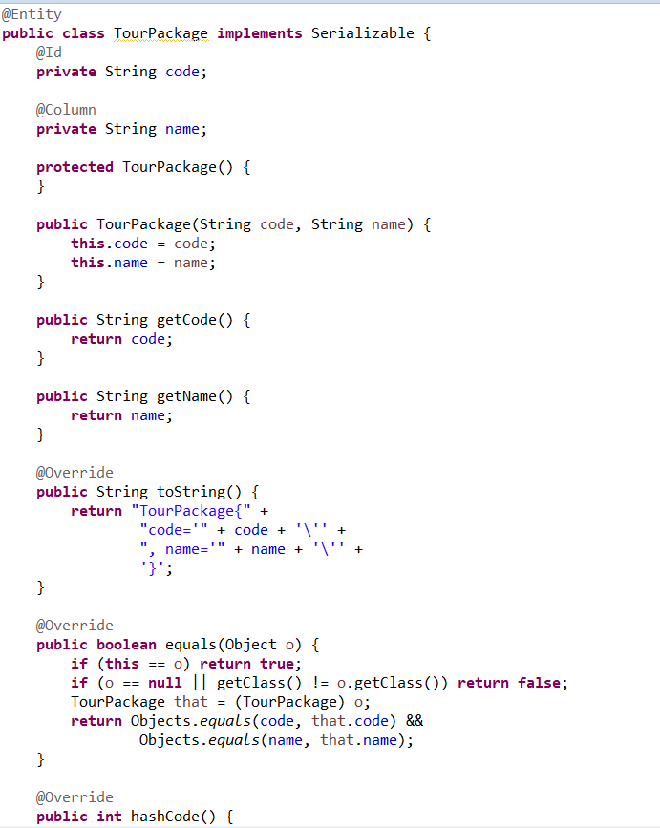

Repository: (Note that “spring-boot-starter-data-rest” depedendancy allows to expose db methods as api. It also exposes a /search api to get all methods in repository explicitly created by us. We can also use @RepositoryRestResource at class level which allows us to give a custom endpoint just like RequestMapping and “@RestResource(exported= false)” can be used at either class or method level to disable the exposure of all or few methods as a api.)

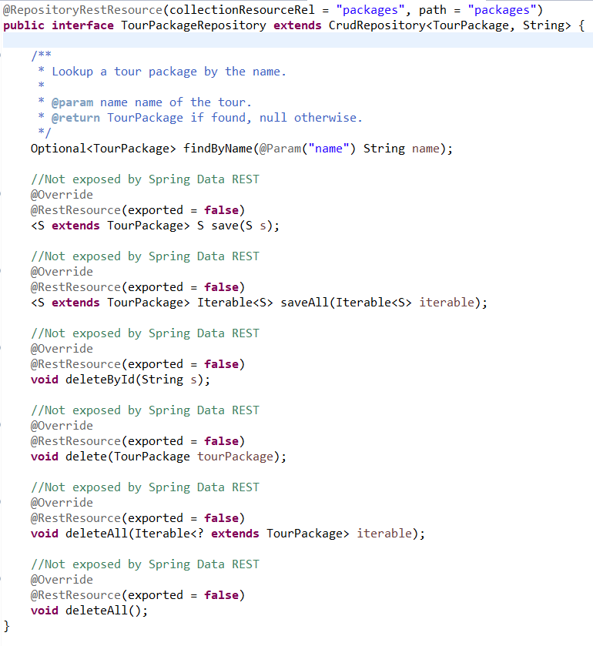

Service Layer:

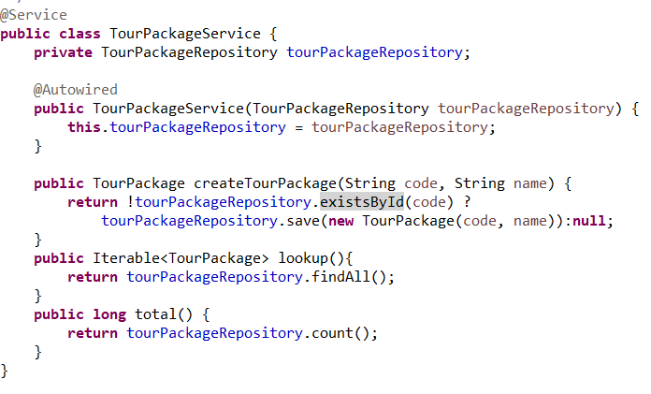

Entity:

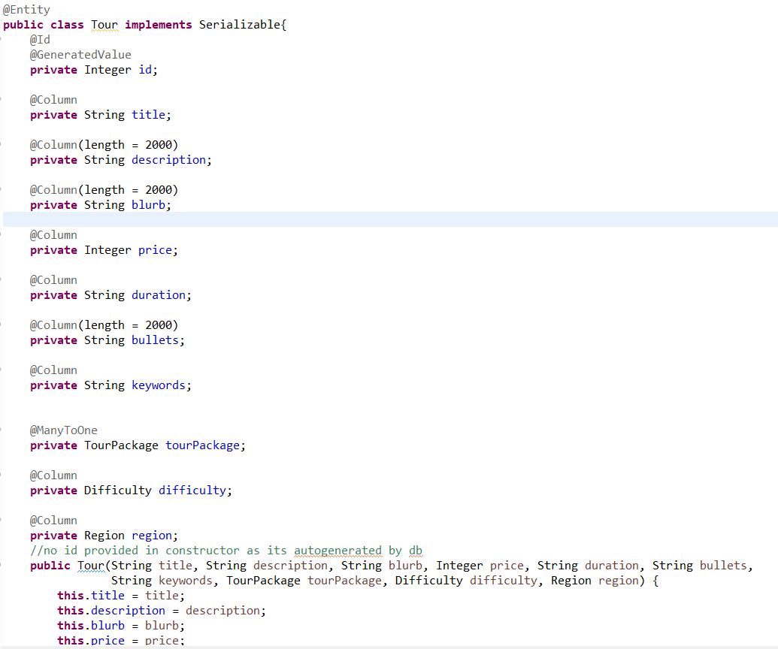

Repository:

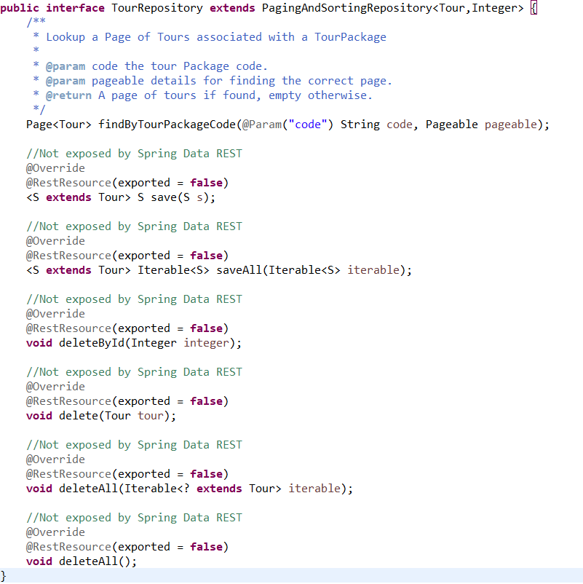

Service layer methods:

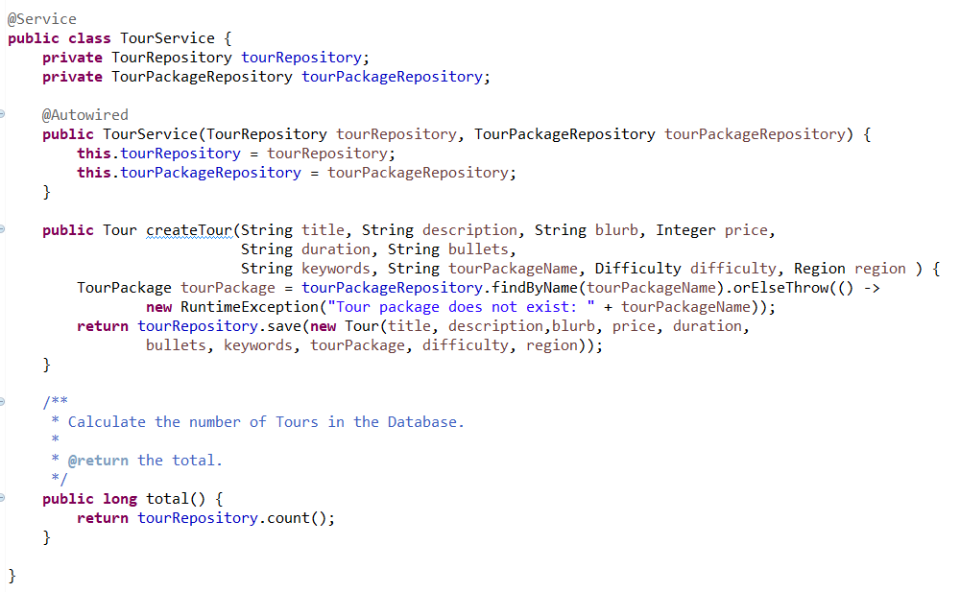

Rules to write a custom repository method:

